**Interaction Design Lab – Week 01**

**Name: Nguyễn Duy Ân**

**Student ID: 2162372**

**Resources:** <http://www.id-book.com/resources_index.php>

**Questions:**

## **A. Describe 16 Important UX Design Principles**

### 1. Meet the users’ needs

The foremost of all UX design principles is to focus on users throughout the [design process](https://www.springboard.com/blog/ux-design-process/). The term user experience itself makes it clear that your work needs to center on improving your users’ experience with your product or service.

Thus, you need to learn what users are looking for in a design (through user testing and other methods). It is possible that a design may seem brilliant to you, but remember that you are not the user.

Springboard alum and UX designer Jeremy Nigh [put it this way](https://www.springboard.com/blog/ux-design-lessons/):

“*All too often I have designed on an island by making assumptions based on what I think an end user needs, crafting pixel-perfect mockups based on my assumptions. I’ve learned that the ‘U’ in UX does not stand for ‘you’! It’s all about the user, so getting outside of my head and engaging with the user is an important step in the design process.*”

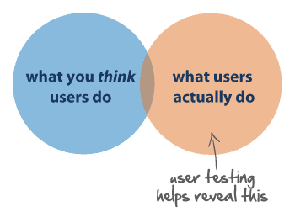

([Source](https://www.i3lance.co.uk/index.php/2015/09/07/ux-user-testing-do-you-need-it-for-your-project/).)

### 2. Know where you are in the design process

For new UX designers who are only just [testing the internship](https://www.springboard.com/blog/ux-design-internship/) waters or are in junior positions, the design process can be overwhelming. A lot of work goes into designing, so knowing your place in the process is significant in several ways.

Firstly, you’ll need to use different tools for each phase, as demonstrated in the graph below. Secondly, knowing your design phase also helps you ask the right questions for user research. For instance, there’s is no point testing the color of a button if you are still figuring out where it should be placed in the design.

### 3. Have a clear hierarchy

It is easy to take hierarchy for granted, but it is a UX principle that ensures smooth navigation throughout a design. There are two chief hierarchies that you need to note. First comes the hierarchy that is associated with how content or information is organized throughout the design.

For example, when you open a website or app, you will note the navigation bar that includes the main sections. This is the primary hierarchy**.** When you click or hover over this bar, you will note further sub-categories of content open up, taking you deeper into the app or site. These are the secondary menus.

This site map shows primary and secondary menus:

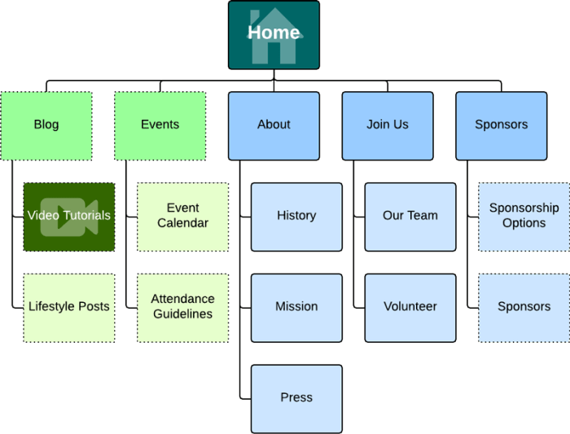

([Source](https://www.lucidchart.com/blog/how-to-make-a-sitemap-using-lucidchart).)

Now take a real example from the [WooCommerce site](https://woocommerce.com/):

There also is a visual hierarchy, which allows users to navigate easily within a page or section. Therefore, to create an easy flowing design for users, you need to place the important content prominently.

The WooCommerce site uses a large font and weight for the main message so that it stands out. The design also uses a different colored button to put emphasis on “Get Started” and encourage action.

### 4. Keep it consistent

Users expect products to share some similarities with other products they regularly use. This makes it easy for them to become familiar with the new product without any additional learning costs. It may sound a little counterintuitive, but the more familiar your design is to others, the faster users can learn to use it, which enhances their experience.

Such consistency also makes the design process easier for the designers, as they don’t have to reinvent the wheel every time they take on a new project. A case in point is the floating action button that has become common among apps, as seen in the Twitter and Google Docs apps below:

### 5. Understand accessibility

An increasingly important rule from among the UX design basics is [designing with accessibility](https://www.springboard.com/blog/accessible-design/) in mind. In simple words, a designer’s responsibility is to make sure that his design is usable for as many people as possible. This means that your design needs to be accessible to people with disabilities too.

To this end, you should remove obstacles from the design layout for problem-free navigation. For example, you can use contrasting colors for the text on the background. This helps visually impaired users (as well as users in low-light settings) read the content on the screen more easily. [Slack](https://slackhq.com/) excels at this on its blog:

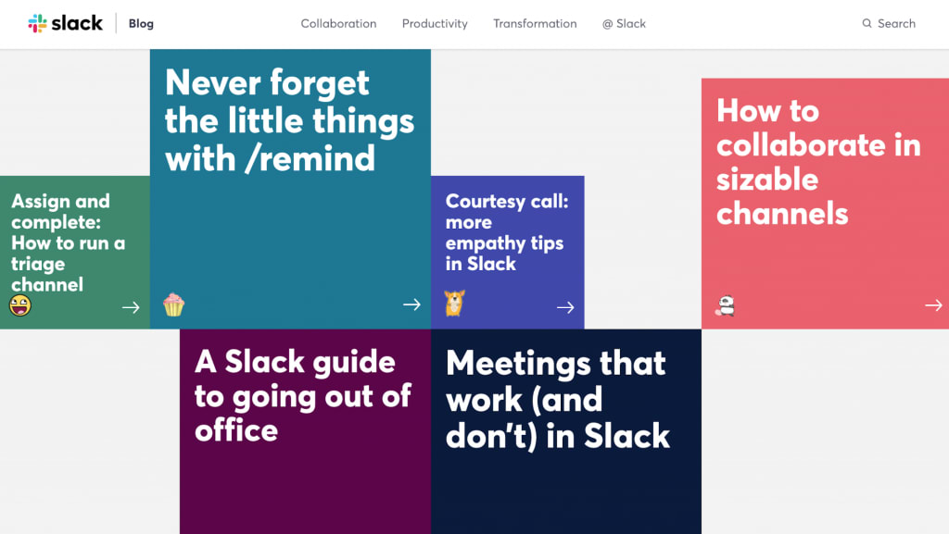

### 6. Context is key

When designing, you need to take into account the [user’s context](https://www.shopify.com/partners/blog/97802374-designing-with-the-users-context-in-mind). Location is a commonly understood contextual factor—are you designing for someone on the go or for someone sitting at a desk? But there are other things to consider, including the time available with the user, her emotional state, the device she is using, the people who influence her, and more.

All these factors help you understand the user’s behavior. Once you have insight into that, you can prepare a design that maximizes user experience. For example, the emotional state of a user would impact how patient or impatient she might be when interacting with the user interface of your product or service, so you’d want to design with that in mind.  
([Source](https://www.appticles.com/blog/2016/03/mobile-vs-desktop-13-essential-user-behaviors/).)

### 7. Usability first

UX design is entirely focused on solving the users’ problems, which makes [usability](https://uxplanet.org/usability-first-why-usability-design-matters-to-ui-ux-designers-9dfb5580116a) of the design one of the most crucial user experience design principles. No matter how aesthetically pleasing your work may be, it won’t strike a chord with the user unless it is safe and easy to use.

A case in point here is website design. Any site that is cluttered is bound to lose visitors. As a designer, your job is to make sure that each icon, button, and snippet of information that is present within the design has a purpose. Concentrate on clarity by bringing only useful features to the user’s attention.

Usability is the reason why prominent buttons and a minimalist design with few elements increase the click-through rate (CTR). Precision Marketing Group [doubled the CTR](https://www.precisionmarketinggroup.com/blog/how-to-improve-your-click-through-rate-with-better-cta-design) on their call-to-action button by changing the shape and size of the button.

[Usability testing](https://www.experienceux.co.uk/faqs/what-is-usability-testing/) asks users to interact with the design. Meanwhile, you take notes to see whether they encounter any problems.

If many people experience similar problems, you will have to make changes to the design to sort out the usability issue. Keep in mind that design is an iterative process and it demands improvements in all stages.

Hence, you should conduct usability tests throughout the UX design process, including before you start your initial design, during the prototyping phases, and at the end of the process.

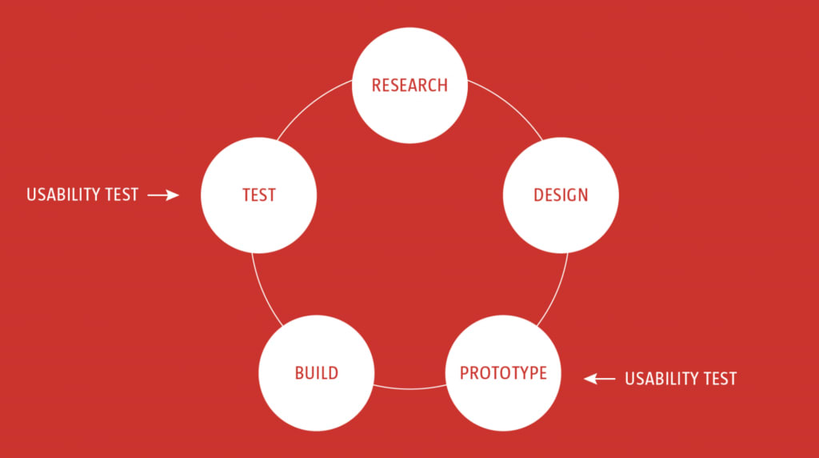

([Source](https://www.smashingmagazine.com/2018/03/guide-user-testing/).)

### 8. Less is more

The less-is-more design principle was originally proposed by the architect [Ludwig Mies van der Rohe](https://en.wikipedia.org/wiki/Ludwig_Mies_van_der_Rohe). For UX, the underlying aim of this is simple: reducing the operational and cognitive costs of the users. In placing value on this, the design’s usability and consistency improve.

The less-is-more approach emphasizes simplicity as opposed to clutter or over-decoration in design. Several celebrated designs have surfaced as a result of this UX design principle, including the iPhone and iPod. In 2007, Apple streamlined the phone’s keyboard in pursuit of the less-is-more philosophy and the iPhone was birthed. Apple’s website also follows the same design principle.

([Source](https://www.apple.com/mac/).)

### 9. Use simple language

Just as simplicity has become a best practice in visual design, UX-focused copywriting should avoid technical terms and opt for simple language. Users are busy, they’re on the go, they’re multi-tasking, so use words in your design that are closest to the user’s thoughts.

[Simple language](https://plainlanguagenetwork.org/plain-language/what-is-plain-language/) is easy to understand, which enhances your design’s user-friendliness.

You need to factor in five points as you choose simple words for your design. These are:

* Audience and purpose of the design: question who your audience is, what information they have, what they need, and what they will want to achieve with your communication
* Structure: ask about the common structures for your communication, what structures your readers are familiar with, and what sequence will be easy to read
* Design layout: focus on the typography, layout, and information graphics
* Expression: consider the tone, verbs, sentence length, jargon, and choice of words your communication will adopt
* Evaluation: have someone review the text you finalize and conduct a usability test

Put simply: use clear and consistent words throughout your design to reduce ambiguity. In this example, the “OK” is unclear. “Yes” is a more logical choice. Got it? (OK!)

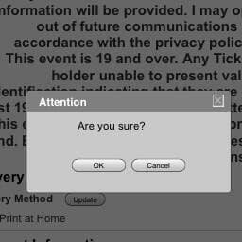

([Source](https://blogs.adobe.com/creativecloud/tell-it-to-me-straight-plain-language-in-ux/).)

### 10. Typography is powerful

Equally important to the words you use in your design is typography. The author of “[The Elements of Typographic Style](http://www.amazon.co.uk/exec/obidos/ASIN/0881792128/monographic-21),” Robert Bringhurst, highlights the role of this UX design principle well. He writes, “Typography is the craft of endowing human language with a durable visual form.”

Typographic choices can significantly impact the way users interpret the language you use, helping enhance or suppress the message. Moreover, [typography](https://www.springboard.com/blog/best-resources-typography-design-online/) can improve UX in multiple ways.

For instance, it can improve accessibility and make the design more user-friendly as you consider a typographic hierarchy. You can take a page from the online publishing platform Medium’s design. [Medium](https://medium.design/project-tnt-4b9b4ea97cda) uses specific typography to make its content more readable.

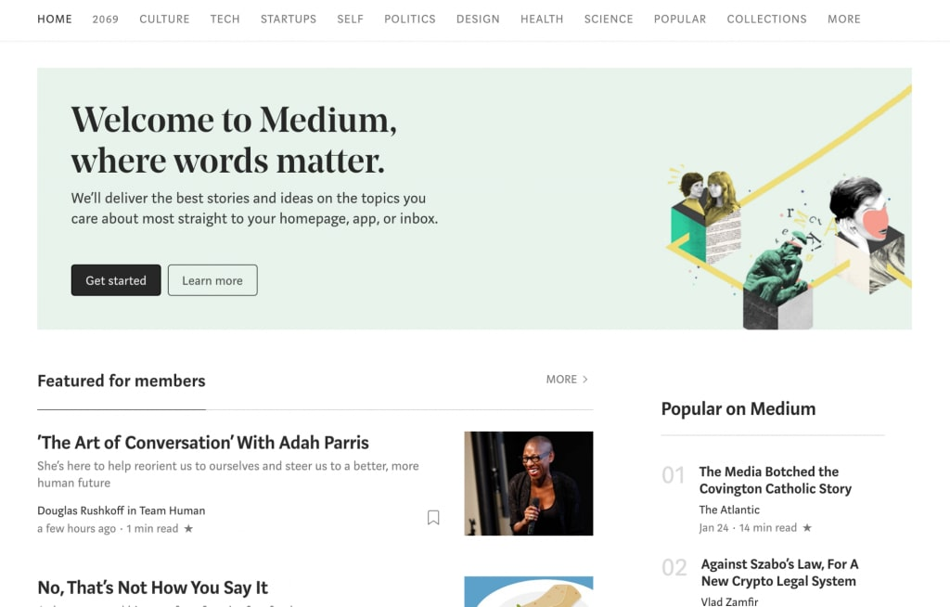

### 11. Feedback matters

Design should be interactive by nature. So, when a user clicks on something, he’ll need a response from the product to understand that his command has been received. Feedback is a crucial way to encourage communication between humans and machines.

Your design may respond in various ways. The clicked icon may change shape, vibrate, discolor, emit light, and so on. Notice how the color reacts as you click a link on the [Zapier](https://zapier.com/) website:

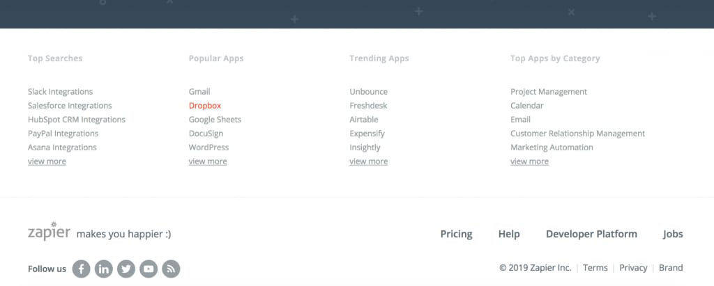

### 12. Confirm before you commit

Accidents happen all the time. One common digital example: a person may unintentionally place an order. (How many parents have had to ask for refunds after their [young kids](https://www.npr.org/sections/alltechconsidered/2013/07/11/201196049/a-quick-history-of-accidental-online-purchases-by-kids) accidentally made a purchase on Amazon or iTunes?) Your design should help correct this, though, because you don’t want to give the user a poor experience. This makes confirmation another one of the essential UX design principles.

Apple asking for confirmation when you empty the trash is one important way this principle is put into use.

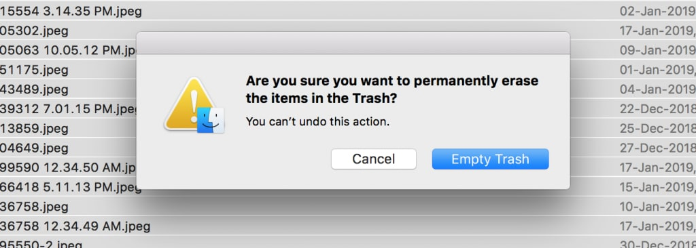

### 13. The user is in control

User control focuses on greater flexibility of use and better control of where a user is within a design or product, enhancing user experience. Furthermore, it allows users to backpedal and recover from errors.

The “upward” icon on a webpage, which allows you to get to the top of the page, is a good example (see below). Similarly, the “cancel” button that allows users to abandon the task they were doing also empowers them. As does the “undo” button, which saves a user from making an unintended action.

([Source](https://www.smashingmagazine.com/2019/01/design-search-mobile-app/).)

### 14. Design with personality

Your design can attract more users if it showcases a character that interests the user persona you are designing for. Users find it hard to connect with a lifeless design, device, or code.

Adding personality to your design gives it the human touch that makes it more attractive and usable (like the [Trello](https://blog.trello.com/) blog).

### 15. Visual grammar

Visual grammar has its roots in graphic design, but it sits at the helm of all visual communication, which plays a significant role in user experience. Visual grammar consists of everything that makes up the visual elements of a design: icons, illustrations, patterns, and more.

Break these down and you will get the core elements of planes, points, and lines, as shown below. Your job as a new designer is to ensure that you understand these elements better for improved visual grammar.

Focus on one point at a time, starting from points, then lines, and finally planes. As you improve on this user experience design principle, you will be able to improve your overall UX design skill set.

([Source](https://www.smashingmagazine.com/2018/01/universal-principles-ux-design/#top).)

### 16. Narrative design

Another one of the most important user experience design principles is narrative design, or telling a story with your design. Two critical storytelling elements are time and rhythm. Time is the pacing your design adopts—for example, how slowly or quickly your narrative is unveiled.

Similarly, rhythm is the pattern of unfolding that your narrative adopts—for instance, the pattern of the series of screens through which the entire design opens up. Too slow a pace can bore your user, not giving her adequate information to hold her interest.

On the flip side, a fast pace can inundate the user with information, which can confuse her. Therefore, you need to balance pace and rhythm. Check out the [Big Apple Hot Dogs](http://www.bigapplehotdogs.com/) website to note how the design uses narrative storytelling:

As you step further along the path to a career in UX design, you’ll want to acquaint yourself with the [common UX terms](https://www.springboard.com/blog/ux-terms/) and UX design basics. Aligning your work with these UX design principles will improve your output and set you up for success as a UX designer.

## **B. Good designs: list two devices/Websites/Mobile Apps that you think are good design. Explain your choices.**

##### **Google Maps**

Everyone has their favorite map or directions application. Mine is Google Maps, which I use whether I'm walking, driving, biking, or taking public transportation. What's special about their mobile website is that it's virtually indistinguishable from their downloadable mobile app.

The screenshots below are taken of their mobile website, but if you're familiar at all with the app, you'll notice they look exactly the same. Not only is the appearance identical, but the mobile website has the speed and functionality of the app.

##### **Typeform**

Typeform is a Barcelona-based tech company with one simple mission: to "make forms awesome." Their desktop website is really beautifully designed, greeting visitors with succinct copy, high-definition videos, relevant animations, and other, more complex design components.

But for mobile users, they recognized that complex design components like video and animations could [significantly affect page load time](https://blog.hubspot.com/marketing/monitor-improve-site-load-time-ht), among other difficulties. That's why they actually removed many of them -- which decluttered the site and simplified the overall mobile experience. The mobile website is a simpler version of their desktop website, and it's still beautifully designed.

## **C. Bad designs:**

##### **1. Based on the design of this Coffee machine:**

###### **What will happen if you follow the steps printed on the machine?**

I will get confused because of a lot buttons. It has so many buttons, This machine is relatively good with many options. But the redundant design, users may be tired of pressing each button.

###### **How would you improve this design**

In my opinions, modernize the equipment is neccessary, this machine should need 1 button for the 4 options in step 1 (choose a size).

For example: when we press 1 time, we have short size. And when we press 2 times, we have tall size, and like that to the full size. Ofcourse, when we press, the button will display how many times we press.

In step 2 (choose a beverage): the disgned was fine for 4 options. But we should add more pictures to show the beverages.

Steps 3 is the finish step of the machine, so I think its fine with the Cancel button, but the Start button should be move to before step 1. Beside that, we should add more choice for cold or ice.

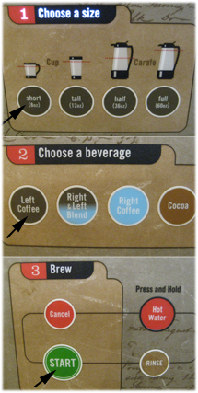

##### **2. Based on the design of this refrigerator:**

###### **How would you open the refrigerator’s door?**

It depends on I am a lefthanded or righthanded. However, I am affaird when I open 1 side, the orther side will open too.

###### **What is wrong with this design?**

So, like I said, the door always has 1 fixed side and 1 side will open. So if we open the refrigerator in this time, maybe the door will broken.

###### **How would you improve this design**

This design is simple to improve, we could fixed 1 side of the door (usually is the right side is fixed).

##### **3. Based on the design of this file drawer:**

###### **How would you open the top drawer?**

Put your finger in the door groove and pull the drawer.

###### **What is wrong with this design?**

I think its fine but maybe we can explain for 2 ways:

+ If the file drawer have 4 wheels and can move, the handle will help you draw this file drawer more easily.

+If the file drawer is in one place and do not have wheels, the handle is redundant.

###### **How would you improve this design**

Should be remove the handle.

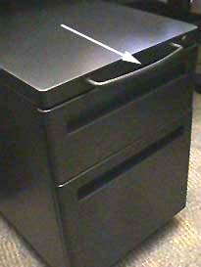

##### **4. The watch is water resistant to 100 m. The instruction booklet that came with the watch was printed... “WARNING: TO MAINTAIN WATER-RESISTANCE, DO NOT PRESS ANY BUTTONS UNDER WATER”. Based on the design of this watch:**

###### **What is wrong with this design?**

The watch is water resistant, so if we put it on the water, and some button to large and maybe the button can collision underwater objects.

###### **How would you improve this design**

We can design the button smaller

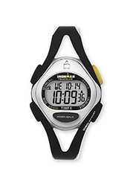

##### **5. Based on the design of this USB connector:**

###### **What is wrong with this design?**

The jack is designed too close to the table, when the USB can not plug into the jack.

###### **How would you improve this design**

Move the jack up.

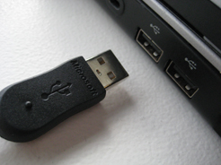

##### **6. Based on the design of this bottles:**

###### **Here is an example of manufacturers packaging different stuff in nearly identical bottles. The picture shows two bottles containing different doses of insulin for treating diabetes. What is wrong with this design?**

Patients will be confused if they’re not clearly read the words written dosage. It to dangerous for tanking wrong bottles.

###### **How would you improve this design**

I think manufacturers should print the number of doses more clearly, larger, each dose has different color for easy identification

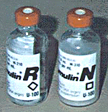

##### **7. Based on the design of this door:**

###### **Here is an example of doors. This picture shows a set of doors in the hallway of a building. What is wrong with this design?**

Normally the door in hallway will have 1 door, not 2 doors like this picture, to saving the space.

###### **How would you improve this design**

Change the door by 1 door.



##### **8. Based on the design of this moist towelettes:**

###### **What is wrong with this design?**

Its fine with this design but to redundant for this, just because the towelettes has 2 protactive plates.

###### **How would you improve this design**

I think its good for the protect by 2 protactive plates so this design maybe not neccesary to improve.

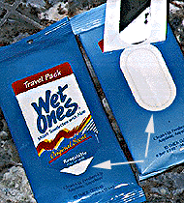

##### **9. Based on the design of this radio:**

###### **What is wrong with this design?**

the water cup holder is really cumbersome when you want to turn on/off the radio or slide the lever.

###### **How would you improve this design**

Move the water cup holder to behind the handlebar lever

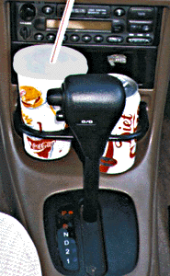

##### **10. Based on the design of this Top-loading VCR:**

###### **What is wrong with this design?**

This VCR has too much button, the users can be confused or uncomfortable to use.

###### **How would you improve this design**

Remove some button, instead, may be 1 button that displays 2-3 functions. Ex: the on/off button. Or we can change color of some button.

